Rousseau, Henri Julian Félix (1844-1910)

A highly original artist who was largely self-taught, the French painter Henri Rousseau is widely considered the most celebrated of naïve artists and an important pioneer of Surrealism. Not known to have travelled outside France, he is best known today for his large jungle scenes, of which he painted at least twenty-five. Full of lush foliage and exotic animals, they were inspired by images in the popular press as well as visits to the Exposition Universelle of 1889 and the Jardin des Plantes, an important botanical garden and zoo in Paris. Besides his jungle scenes, Rousseau also painted history paintings celebrating the still young Third Republic, suburban landscapes showing the life of the petite bourgeoisie, still lifes and portraits, such as the full-length Portrait of a Woman (c. 1895) and the two smaller portraits representing the artist and his second wife (c. 1900-3) once owned by Pablo Picasso. Not lacking in confidence, but always striving for recognition, Rousseau appreciated the support he received from the poet Guillaume Apollinaire and the painter Robert Delauney, both of whom became close friends. Whereas certain members of the avant-garde admired Rousseau’s paintings for their charm and innocence, others, however, regarded them as outright eccentric.

Rousseau was born to petit-bourgeois parents in Laval, a market town in North West France, in 1844. Following school, he worked as a scribe for a local solicitor. Having cheated him out of a small sum of money, he enrolled in the military, quite possibly to evade punishment. In 1864, he still had to spend one month in prison; it was not to be his last brush with the law. In 1868, Rousseau married Clémence Boitard and moved to Paris. Here he joined the city’s toll service as a customs clerk, a post that earned him the nickname Le Douanier, meaning ‘the customs officer’. Aged around forty, Rousseau took up painting as a hobby, admiring such Salon painters as Eugène Delacroix and Jean-Léon Gérôme. By 1890, as is evident from his self portrait Myself: Portrait Landscape, he perceived himself as a painter. Showing Rousseau in full length with his palette on a quay alongside the river Seine, the painting also celebrates modernity and pays tribute to two historic events with which the artist closely identified: the escape of the French republican politician Léon Gambetta by hot air balloon from besieged Paris in 1870 and the Exposition Universelle of 1889, for which the Eiffel Tower was built.

In 1891, Rousseau painted his first and arguably finest jungle scene, Tiger in a Tropical Storm (Surprised!). Exhibited at the Salon des Indépendants in 1892, it met with acclaim as well as mockery. In 1893, Rousseau took early retirement to paint full time, teaching art and music to earn at least a meagre income. He soon ran into financial difficulties, but led a fulfilled artistic and personal life. After losing his first wife to tuberculosis in 1888, he married Joséphine Noury in 1899; her death only four years later left him inconsolable. The following year Rousseau returned to painting jungle scenes, resulting in the violent Scouts Attacked by a Tiger (1904) and The Hungry Lion Throws Itself on the Antelope (1905). Gradually calm returned, as echoed in The Snake Charmer (1907) and The Dream (1910). The latter shows, as we know from an explanatory poem by Rousseau, Yadwigha in a beautiful dream. Having fallen asleep on a Louis-Philippe couch right in the middle of the jungle, the female nude has been woken up by the sound of a snake charmer and is as surprised as the animals around her to find herself where she is. Exhibited to general acclaim at the Salon des Indépendants in 1910, the painting mixes the traditional and modern, domestic and exotic, real and surreal. Having finally received the recognition he had always wanted, Rousseau died a few month later, heartbroken and impoverished.

Apollinaire had seen in Rousseau the ‘Paolo Uccello of [the 20th] century’. Further to the legendary banquet he organised together with Picasso in honour of Rousseau in 1908, he also referred to him in his poetry. However, he mystified him more than he allowed him reality. By contrast, the German collector-dealer Wilhelm Uhde sought to present Rousseau as he was. To this end he organised a large retrospective exhibition at the Salon des Indépendants in 1911 and published a first monograph on the artist, also in 1911. By the mid-1920s, Rousseau’s reputation was firmly established: The Snake Charmer was acquired by the Louvre in 1925, The Sleeping Gypsy (1897) sold for a staggering 520,000 francs in 1926.

References and further reading:

Adriani, G. (2001), Henri Rousseau, New Haven & London: Yale University Press.

Certigny, H. (1984), Le Douanier Rousseau et son temps: biographie et catalogue raisonné, 2 vols., Tokyo: Bunkazai Kenkyuujou.

Green, C. (2005), Picasso: Architecture and Vertigo, New Haven & London: Yale University Press.

Green, C. and F. Morris (eds.) (2005), Henri Rousseau: Jungles in Paris, London: Tate (exh. cat.).

Hoog, M., Lanchner, C. and W. Rubin (eds.) (1985), Henri Rousseau, New York: Museum of Modern Art (exh. cat.).

Sochaczewer, H. (1927), Henri Rousseau: Novelle, Potsdam : Kiepenheuer.

Ireson, N. (2005), Interpreting Henri Rousseau, London: Tate.

Shattuck, R. (1958), The Banquet Years. The Arts in France, 1885-1918: Alfred Jarry, Henri Rousseau, Erik Satie, Guillaume Apollinaire, New York: Harcourt, Brace & Co.

Image suggestions:

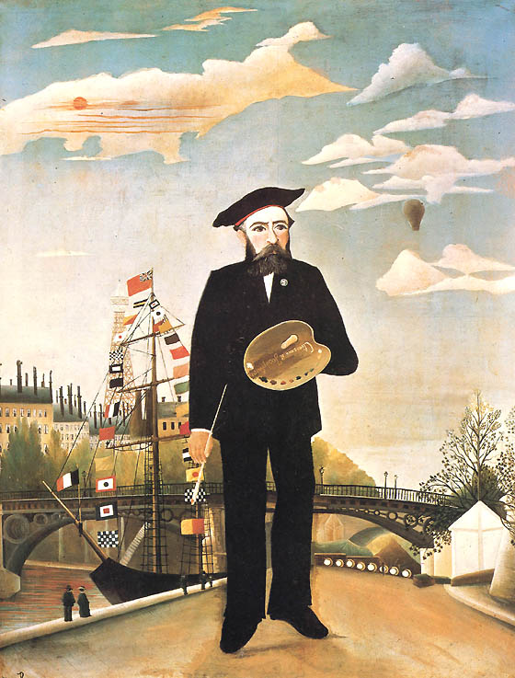

Henri Rousseau, Myself : Portrait Landscape, 1890. Oil on canvas, 146.0 x 113.0 cm. Národní Galerie, Prague.

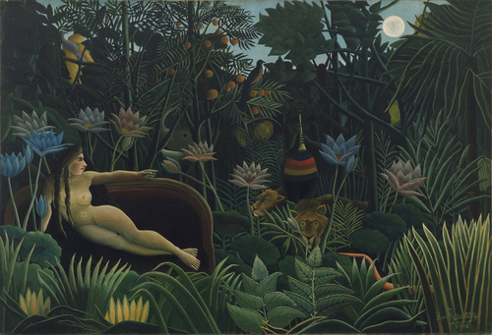

Henri Rousseau, The Dream, 1910. Oil on canvas, 204.5 × 298.5 cm. Museum of Modern Art, New York.

